## How to convert State Plane from one projection to another. This is to convert coordinates from the Kentucky North/South Zone to the Kentucky Single Zone in ORD.

ORD Version

This workflow is intended for OpenRoads Designer version 10.12.02.4. The directions outlined below may respond differently in other versions of the Program.

Contact Information

This workflow was produced by Perry Semones and John Sudduth of KYTC Survey Coordination. Please send all questions, errors or overall concerns to [KYTC CADD Support](https://forms.office.com/Pages/ResponsePage.aspx?id=TX9812fXH0a2JQYoeS6eKs9cl-xn951EuYQBlK5fyyZUQ0JSOUtWTlJVWDNZS0xBNVJXQkZTS1E1NSQlQCN0PWcu) or call 502-564-3280.

Important Note

It is important to know that although this specific workflow was done translating from South Zone to Single Zone, this same workflow also applies to translating North Zone to Single Zone as well.

----------------------------------------------------------------

Open a new dgn file. do not use a file that you “cleaned out.” Start with a totally new dgn file. Make sure you are in the Survey workflow.

Since we are importing KY South Coordinates we need to set that up in ORD.

This would be the file that contains coordinates in the South Zone.

Click on Utilities and you will see a Coordinate system icon. Click on the globe icon.

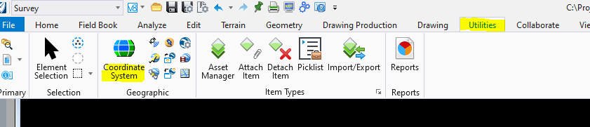

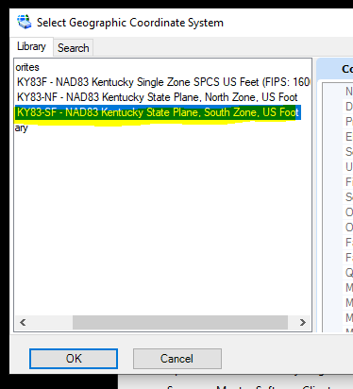

This lets ORD know that the incoming coordinates are KY South Zone.

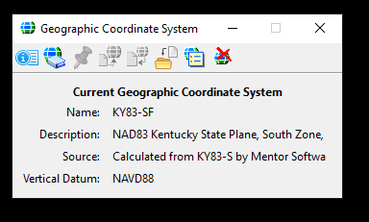

## Next, import the file that contains the South Zone Coordinates. Normally this would be a CSV file. If you need to know how to do this step, see “How to Import Field Data Using a CSV File in ORD” on the Survey Coordination web site.

When a new DGN file is open, it defaults to Kentucky Single Zone. Click the second icon from the left.

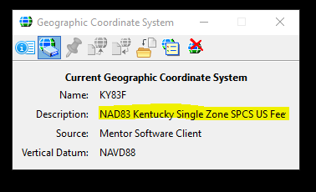

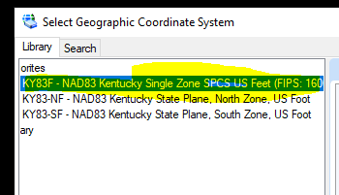

Choose the Kentucky Single option. Then click OK.

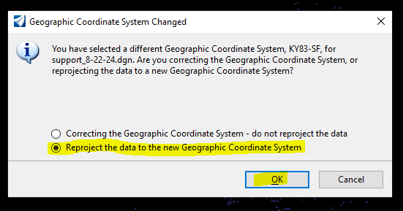

Then click OK. you should see a conversion take place. the coordinates should now be what coordinate system you specified.

This converted the Kentucky South Plane Coordinates into Kentucky Single Zone Coords.

You may have to do a Fit View to see the final coords.

If you see Kentucky Single coordinates in this range and no other factors were involved, then the transformation should be good.